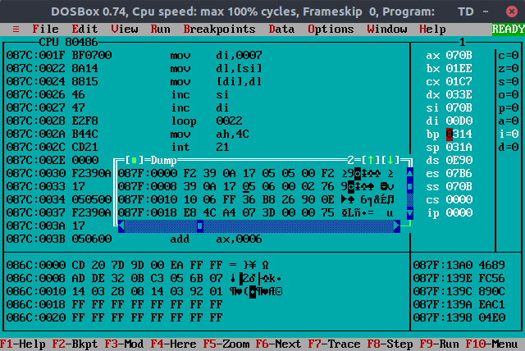

8 Bit Block Copy Using Register

16 Bit Block Copy Using Register

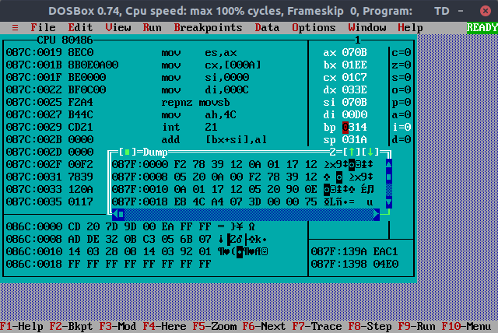

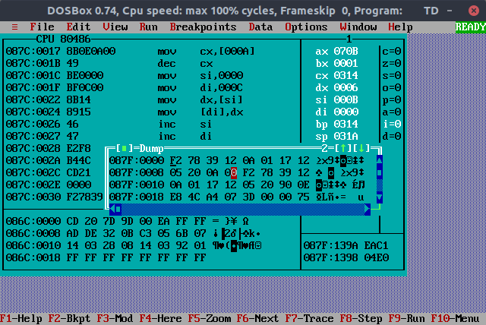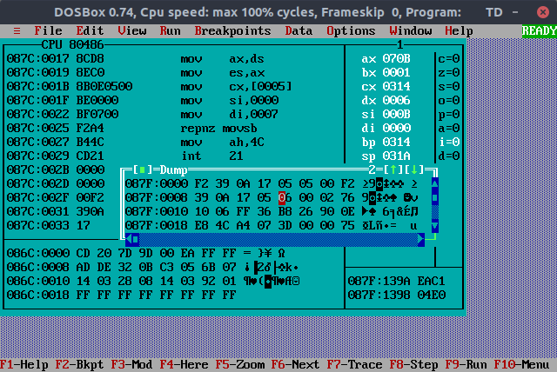8 Bit Block Copy Using String Instruction

16 Bit Block Copy Using String Instruction